GREENWOOD COLLEGE

Mathematics Methods Units 3 & 4

Test 5 Logarithmic Functions 2019

Name Mark /33

All electronic devices must be switched off and in bags.
Access to Formulae Sheet allowed. No notes.
No calculators allowed in this section. Time limit 35 minutes.

1. [ 4,4 = 8 marks]

Solve the following equations using logarithms:

a) $2×3^{x-2}=162$ b) ${25}^{x}-3×5^{x}=0$

2. [ 4 marks]

Solve for $x$: $\log_{4}{x^{3}+\log_{2}{\sqrt{x}=8}}$

3 [2,2 = 4 marks]
Determine the following antiderivatives:

a) b)

4. [2,1,2 = 4 marks)

a) Determine the derivative of y =

b) Hence find

c) Use your result to find the exact value of

5. [3 marks]

Show that $\frac{d^{2}}{dx^{2}}(sin(\log_{e}{x))=}{\frac{\cos{(\log_{e}{x)+}sin(\log_{e}{x)}}}{-x^{2}}}$

6. [ 2,3 = 5 marks]

a) Differentiate $xlnx-x$ to find $\int{lnx dx}$

b) Hence determine the shaded area shown under the function $f\left(x\right)=\ln{x}$.

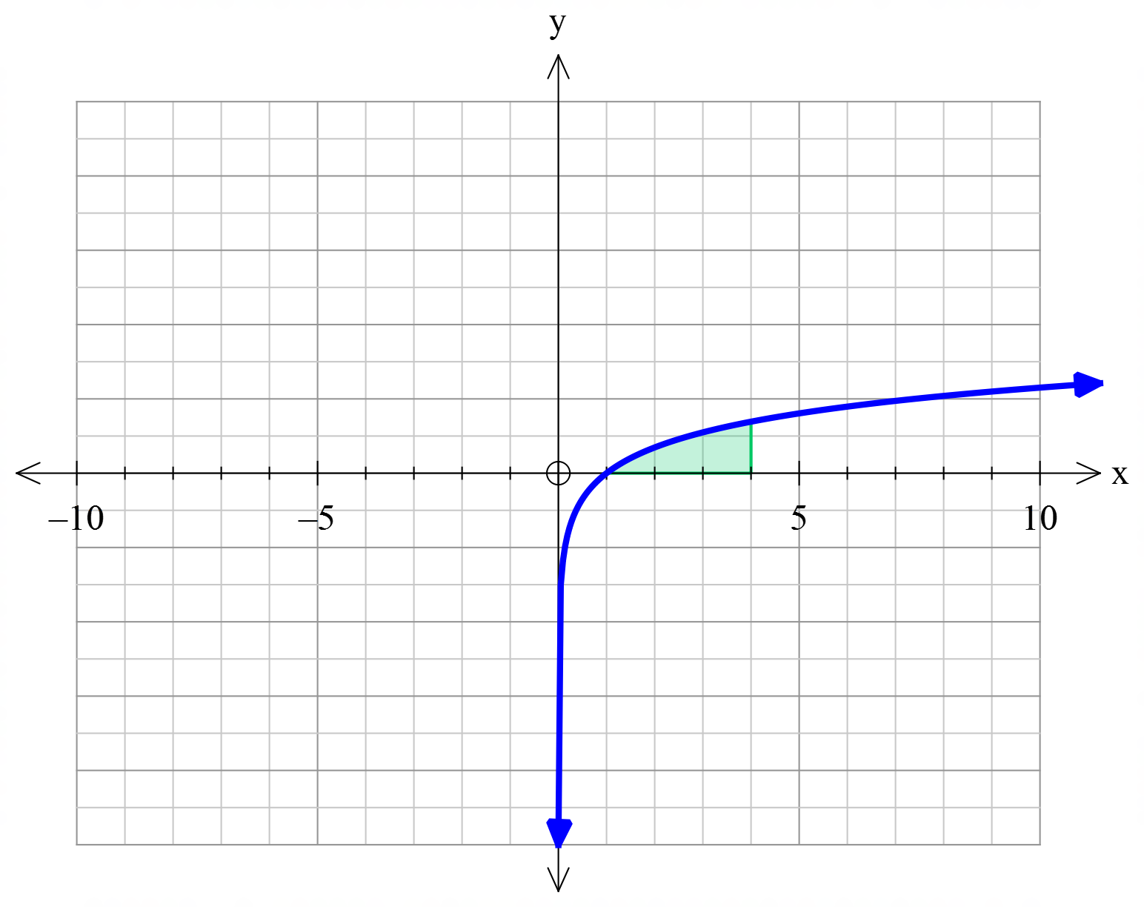

7. [ 2,3 = 5 marks]

Both graphs A and B shown below are in the form $f\left(x\right)=\log\left(x-a\right)+b$. State the variables $a$ and $b$ for each graph.

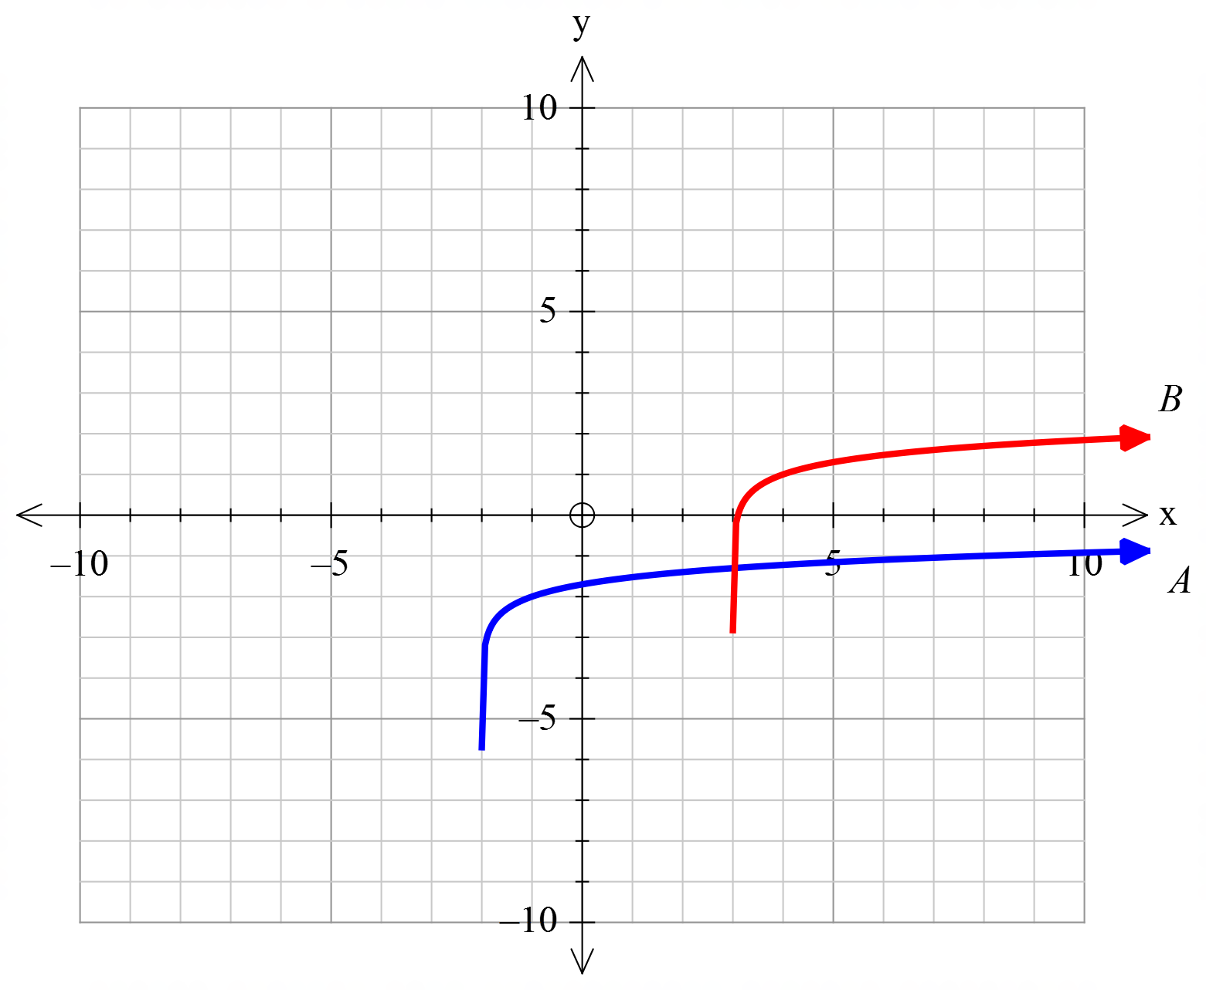

END OF SECTION
GREENWOOD COLLEGE

Mathematics Methods Units 3 & 4

Test 5 Logarithmic Functions 2019

Name Mark /23

All electronic devices must be switched off and in bags.
Access to Formulae Sheet and one sheet of A4 notes allowed. Use of approved calculators is assumed in this section.
Time limit 20 minutes.

8. [ 1,1,2 = 4 marks]

Let $f\left(x\right)=\int_{1}^{x}{\frac{1}{t}dt}, x>0$

a) State a simplified expression for $f(x)$.

b) Hence evaluate $f\left(5\right)$, rounded to 2 decimal places.

c) State an exact value for $f'(5)$.

9. [ 2,2,2 = 6 marks]
A clothing manufacturer makes two popular items of clothing: jumpers and cardigans.
The profit , $P$ in tens of thousands of dollars from the manufacture and sales of $x$thousand jumpers is given by $P_{j}=2\log{(x+0.75)}$. The corresponding profit for cardigans is given by $P_{c}=3\log{(x+0.5)}$. Assuming all the items produced are sold, determine:

a) the number of jumpers needed to be produced for the jumpers product line to break even.

b) The number of each item that needs to be produced and sold for the two product lines to make the same profit

c) the number of jumpers that need to be produced for the jumpers to make more profit than the cardigans.

10. [3,3,1 = 7 marks]
a) Show that the gradient of the curve at the origin is 0.

b) The graphs of , and are shown below.
- Determine the exact value of , , given that the shaded region has an area of 6 square units.

ii) Determine the exact area between and the -axis from to .

11. [ 2,2,2 =6 marks]

At the start of a plague of grasshoppers the population doubles every 4 days.

a) Explain why the Population after $t$ days might be modelled by the equation
$P\left(t\right)= P_{0}×2^{\frac{t}{4}}$

b) How long will it take the population of 2000 to grow to 64000 ?

c) Show that the equation for $t$ in terms of $P$, given an initial population of 2000, can be expressed as .
$$t=\frac{4\log{P/{2000}}}{\log{2}}$$

END OF PAPER

